DAT 510 uCertify Lab Activity Worksheet

Aubrey Waddle
Module 5

Module Labs

5.8.1 Analyzing Data Using Box Plots and Violin Plots

5.8.2 Analyzing Data Using Scatter Plots and Line Charts

5.8.3 Analyzing Data Using Bar Charts

5.8.4 Analyzing Data Using Heat Maps

Lab Screenshots

5.8.1 Analyzing Data Using Box Plots and Violin Plots
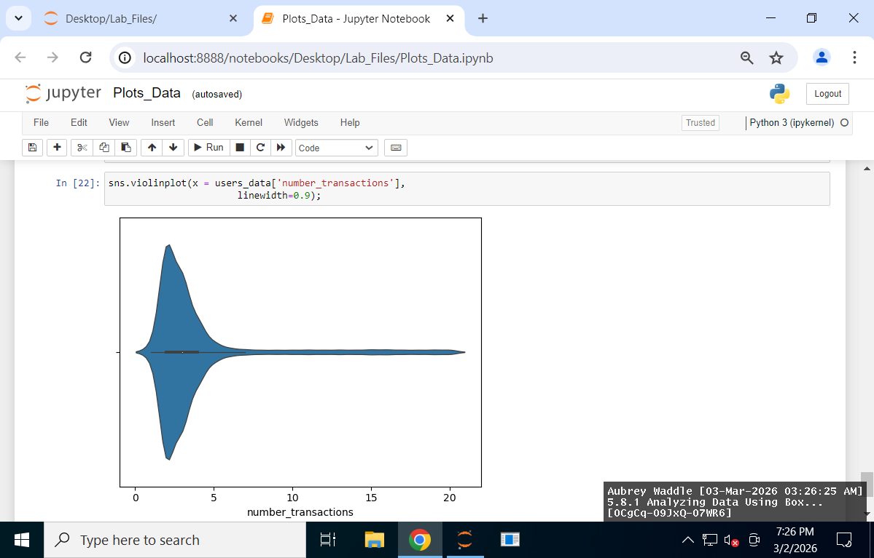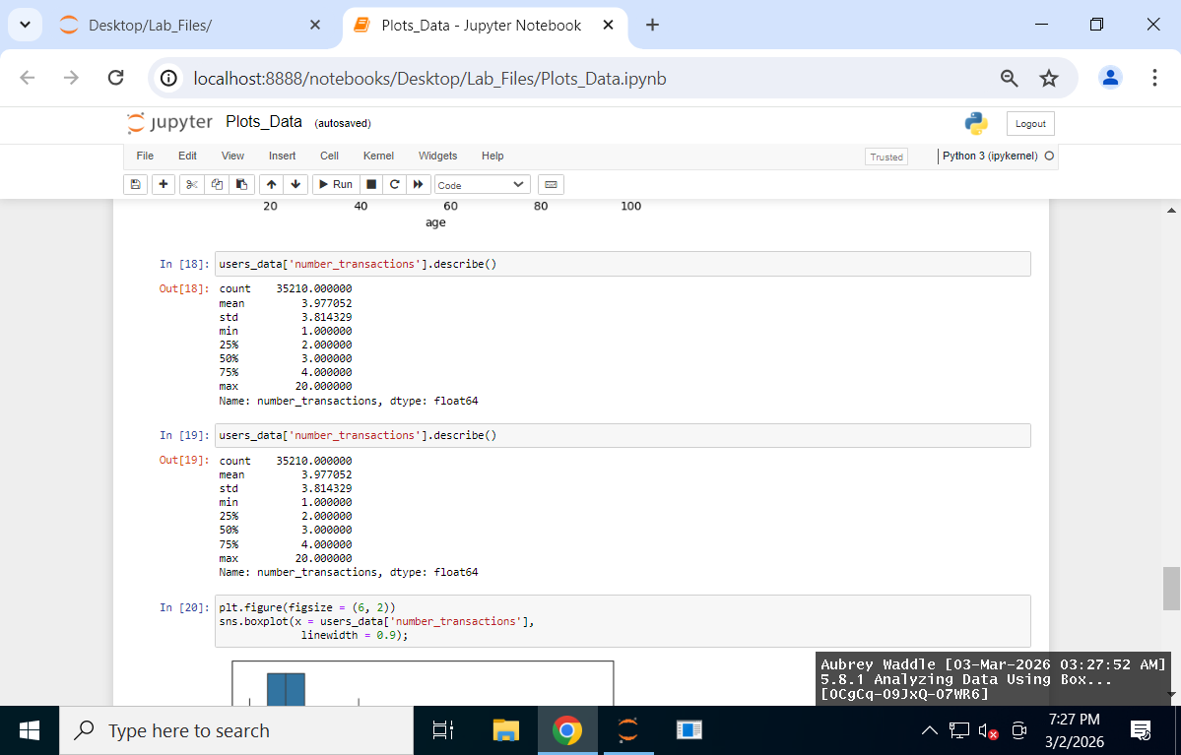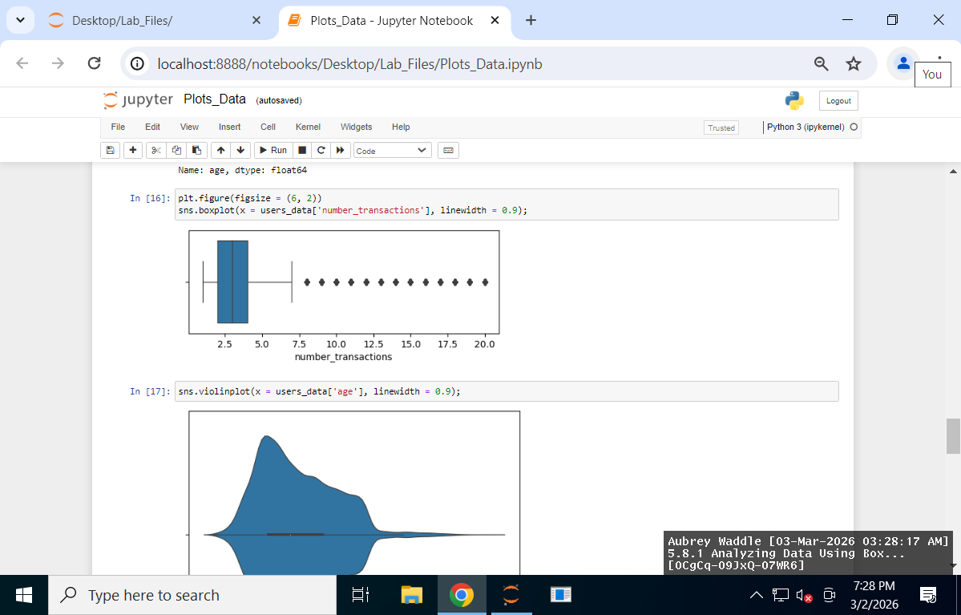
5.8.2 Analyzing Data Using Scatter Plots and Line Charts

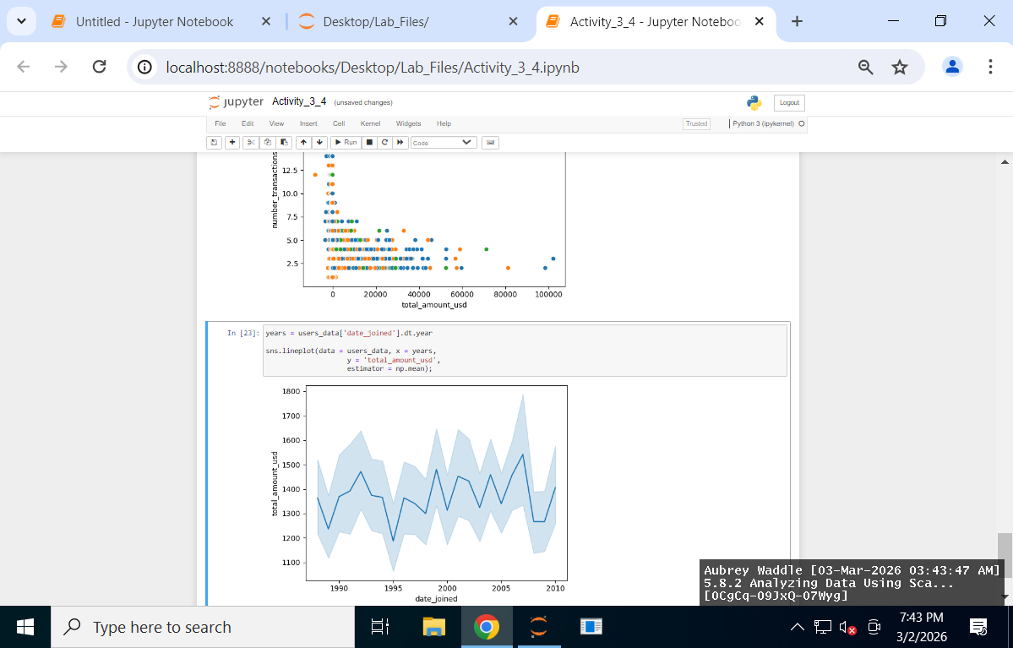
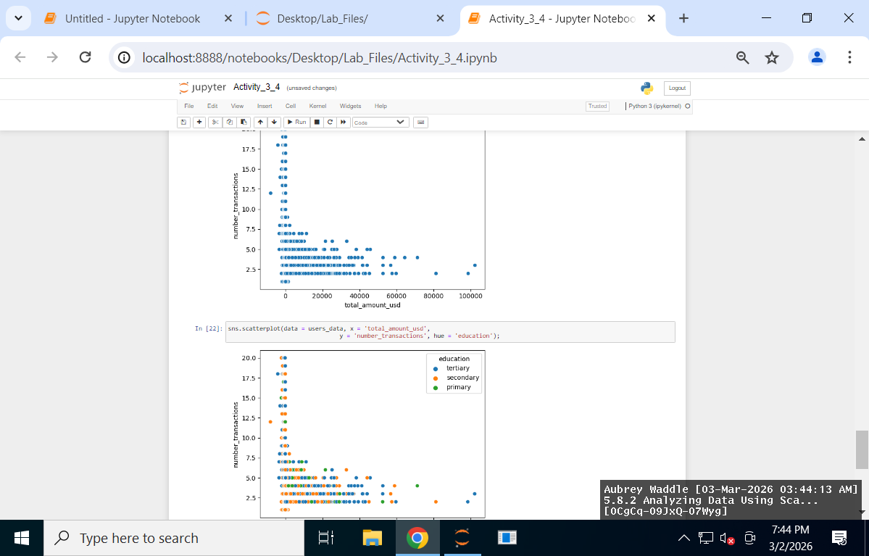

5.8.3 Analyzing Data Using Bar Charts

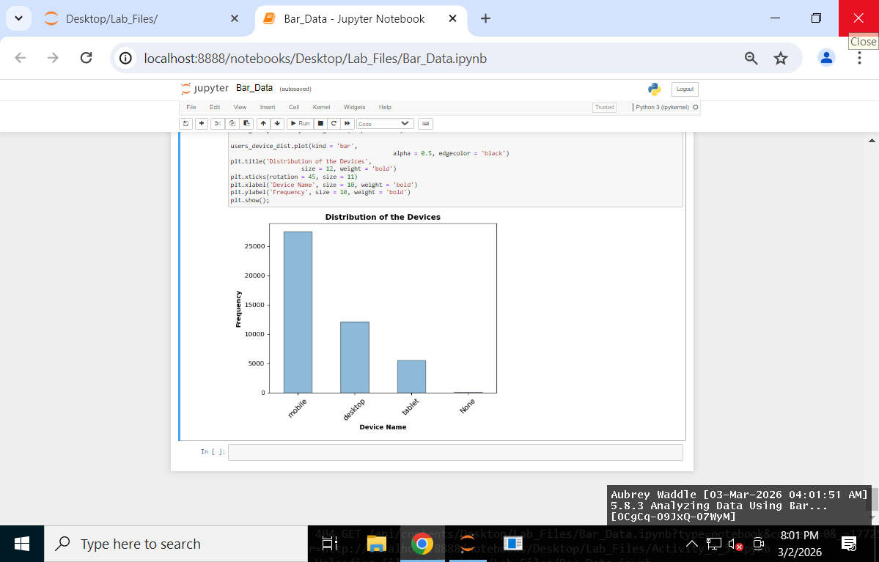

5.8.4 Analyzing Data Using Heat Maps

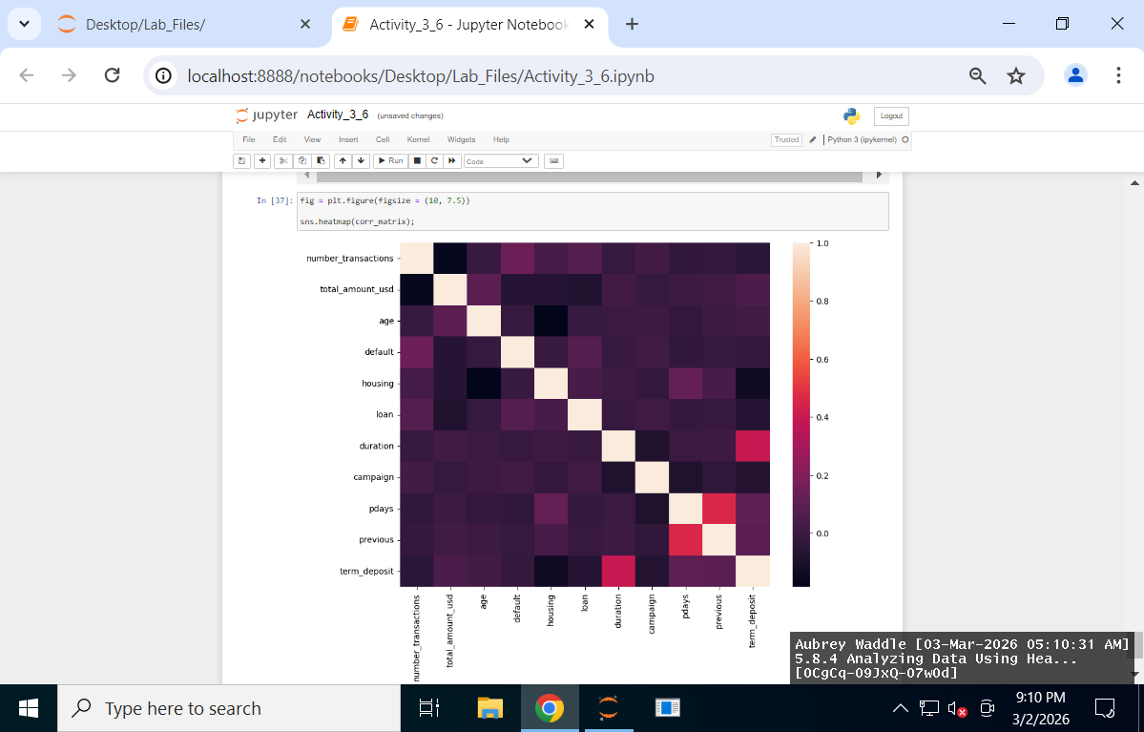
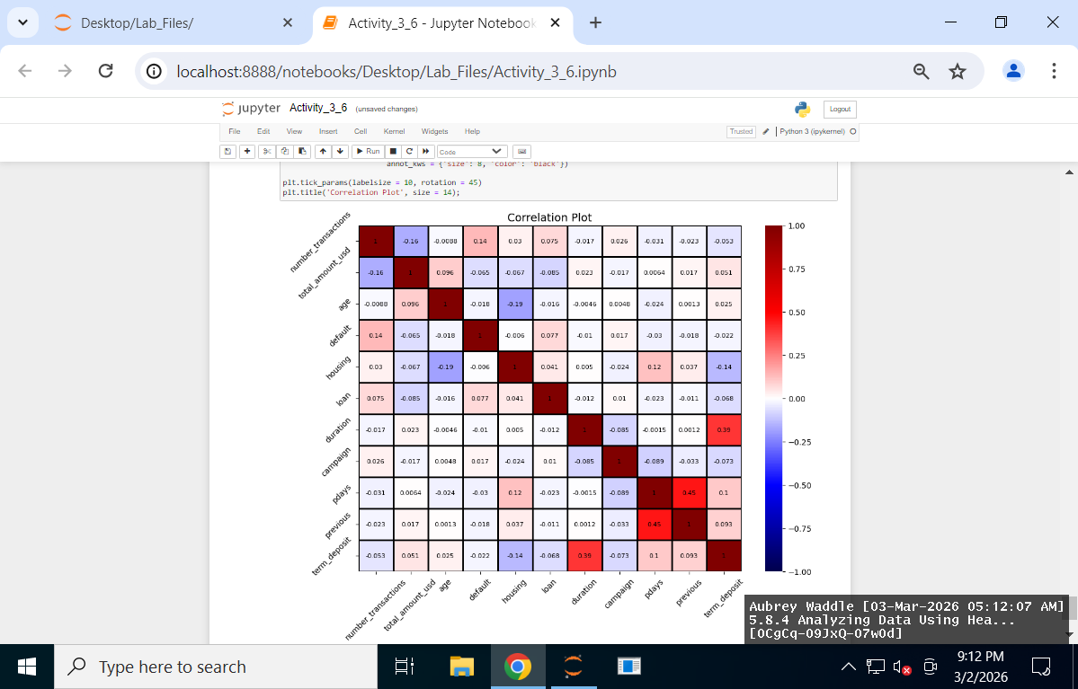

Lab Reflection

5.8.1 Analyzing Data Using Box Plots and Violin Plots:
This week's lab focused on using Jupyter Notebook for Python exploratory data analysis. I mostly used Seaborn, Matplotlib, and Pandas to summarize and visualize user data. By creating summary statistics for variables like age and number_transactions using the.describe() method, I was able to easily understand the count, mean, standard deviation, and general distribution of the data. I then created box plots and violin plots to graphically analyze skewness, spread, and potential outliers. In number_transactions, the box plots were very useful for identifying extreme values, as several high-end outliers were easily visible. The violin plots added another layer of information about the regions where values were concentrated by showing the density and shape of the distribution. While distribution is displayed in both visualizations, the box plot focuses more on quartiles and outliers, while the violin plot emphasizes distribution form and frequency. These methods would be useful for financial analysts, product teams, and business analysts that need to spot trends in consumer behavior fast.

    - Analyzing Data Using Scatter Plots and Line Charts:

I used Seaborn to make a couple scatter plots and line graphs to look at the relationships between the different variables in this part of the lab. I created a scatter plot showing the relationship between number_transactions and total_amount_usd, which helped me see how spending might change depending on how often someone makes transactions. I also added education as a color variable so I could see how different education levels were spread across the spending patterns. I also made a line plot that shows the average total_amount_usd by year. I used the dt.year function along with estimator = np.mean to do this. This made it easier to notice general trends over time instead of just looking at individual data points. Techniques like this could be really useful for finance teams or business analysts who are trying to understand customer spending behavior and spot trends that could help with future planning or decision making.
    - Analyzing Data Using Bar Charts:

In this lab, I looked at several categorical variables using value_counts() along with a few bar charts. Even though there were some missing values in the data, I was still able to get a pretty clear idea of how things like job, marital status, education, contact, outcome, default, and device were distributed. This helped me see which categories showed up the most and how they were spread across the dataset. Additionally, I created bar charts that were both vertical and horizontal, which helped with group comparison. Given the length of some of the labels, this was quite useful. I soon discovered that the majority of users were married, that mobile devices were used more frequently than PCs or tablets, and that many of them held managerial or blue-collar positions. Before generating projections or focusing on particular groups, marketing teams, risk analysts, or business decision makers may find it useful to learn more about the demographics or behavior of their clients.

    - Analyzing Data Using Heat Maps:
In this part of the lab, I used the .corr() function to create a correlation matrix so I could look at the linear relationships between the numerical variables in the dataset. This helped me quickly see which variables had positive or negative relationships and how strong they were. Most of the correlations were pretty weak, but there were a couple that showed moderate relationships that might be worth exploring a little more later on. After that, I used Seaborn heatmaps to visualize the correlation matrix. The first heatmap just gave a simple overview of the correlations. Then I made a second version where I added a custom color map, labeled the correlation values, and adjusted the formatting so it was easier to read. That made it a lot easier to notice patterns right away. Techniques like this are really useful for feature selection and predictive modeling since they help analysts figure out which variables might actually matter before building regression or classification models.

